

Practices for Secure Software Report

Table of Contents
Document Revision History 3
Client 3
Instructions 3
Developer 4
1. Algorithm Cipher 4
2. Certificate Generation 4
3. Deploy Cipher 4
4. Secure Communications 4
5. Secondary Testing 4
6. Functional Testing 4
7. Summary 4
8. Industry Standard Best Practices 4

Document Revision History

Version | Date | Author | Comments
1.0 | 10/19/26 | Adam Denny | Document creation

Client



Instructions

Submit this completed practices for secure software report. Replace the bracketed text with the relevant information. You must document your process for writing secure communications and refactoring code that complies with software security testing protocols.

- Respond to the steps outlined below and include your findings.
- Respond using your own words. You may also choose to include images or supporting materials. If you include them, make certain to insert them in all the relevant locations in the document.
- Refer to the Project Two Guidelines and Rubric for more detailed instructions about each section of the template.

Developer
Adam Denny

Algorithm Cipher

I recommend SHA-256 for integrity checks, AES-256 (GCM mode) for stored data, and RSA-2048 with TLS for data in transit. SHA-256 is a one-way hash function. AES is a symmetric block cipher. RSA is an asymmetric algorithm. I used the SHA-256 and the RSA-2048 certificate.

SHA-256 gives a 256-bit output (64 hexadecimal characters). A small change in the input gives a completely different output, and nobody can reverse it. MD5 and SHA-1 are not safe, because real collisions were found. The certificate uses SHA256withRSA. AES-256 uses a 256-bit key. An RSA key of 2048 bits gives about 112 bits of security, which NIST accepts.

Key values need secure random numbers. SHA-256 uses no random numbers, because the same input must give the same checksum. A symmetric key (AES) is one shared secret. It is fast, but it is hard to share safely. An asymmetric key (RSA) is a public and private pair. It is slower, but it solves the sharing problem. TLS uses both: RSA proves the server identity, and AES encrypts the traffic.

Certificate Generation
Insert a screenshot below of the CER file.
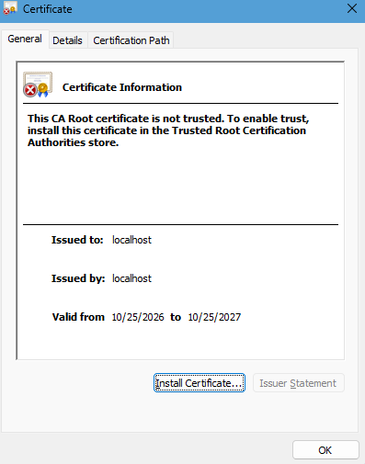

Deploy Cipher
Insert a screenshot below of the checksum verification.
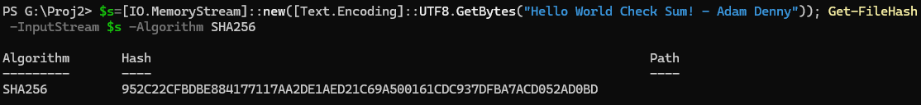

Secure Communications
Insert a screenshot below of the web browser that shows a secure webpage.

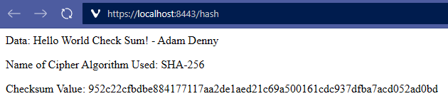

Secondary Testing
Insert screenshots below of the refactored code executed without errors and the dependency-check report.
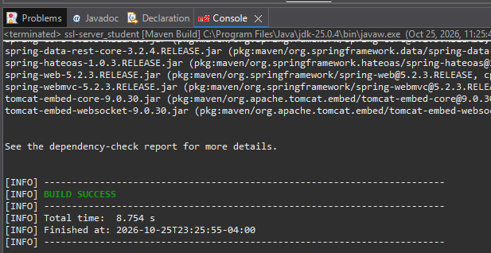

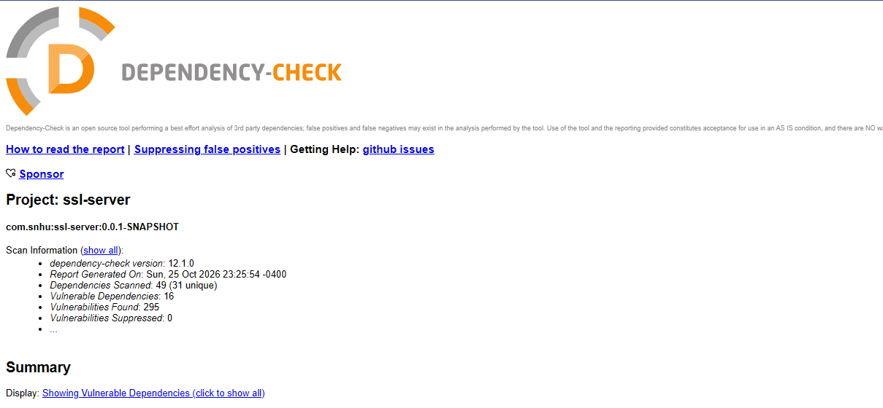

Functional Testing
Insert a screenshot below of the refactored code executed without errors.
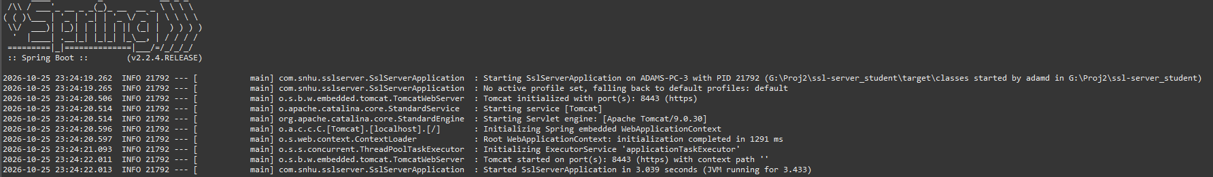

Summary

I added one layer at a time and ran the application after each one. First I made the certificate, then the checksum, then HTTPS, then the tests. The layers work together, as the checksum protects integrity, HTTPS protects data in transit, and testing finds what remains.

Industry Standard Best Practices

I used the standard Java cryptography library and did not write my own algorithms. I chose NIST-recommended algorithms and key sizes, and I rejected MD5 and SHA-1. I added no new dependency, did not change any existing endpoint, and tested after each change, so the existing security stayed in place.

Secure coding lowers the chance of a data breach, which costs a financial company money and customer trust. It also helps the company follow regulations or rules such as GLBA and PCI DSS, and it costs less to fix problems early than after release.

